# Week 7 Homework

1. Leveraging our “Top-Down” design approach, update the model so that the Buttons and the Button Overlay Part get wider along with the Frame when the small speaker is moved. When the small speaker is moved outwards 2 inches, it should look like this:

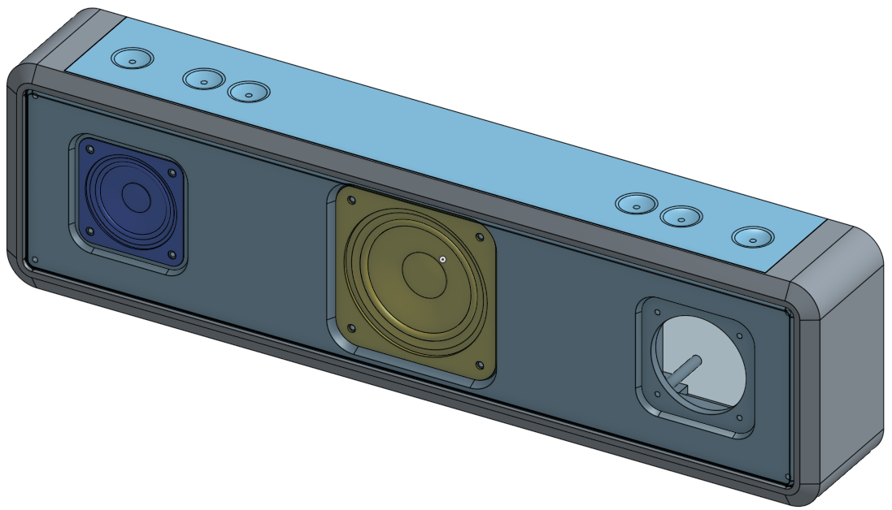

1. What are some other ways we could incorporate Top-Down design? Pursue a design with more than 3 speakers. For example, by leveraging sketch and feature patterns, it’s actually quite easy to create a robust design with 9 speakers!

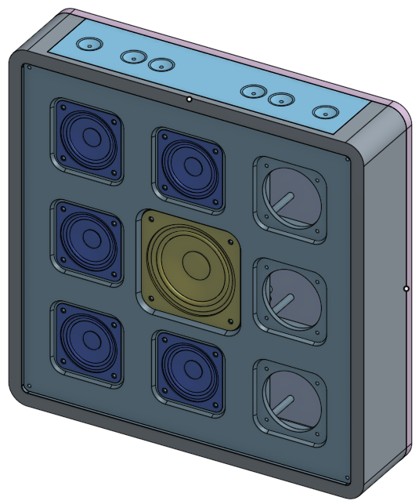 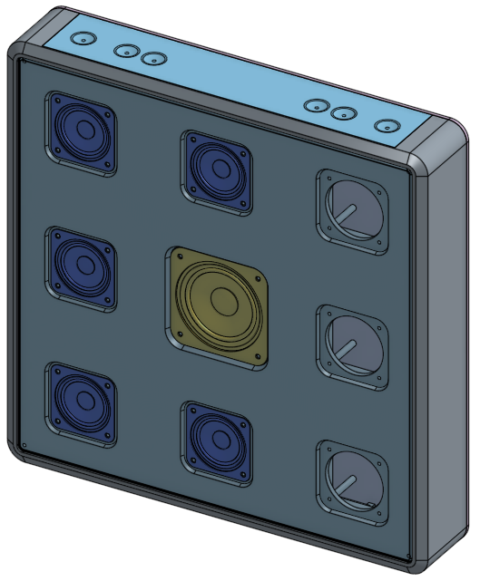

1. Create a mesh grill for the front, perhaps using one of the FeatureScript features such as this pentagon fill pattern:

